Nama : M. Faris Daffarindra

NIM : F1E324003

Prodi : Informatika

**Lab 7**

1. 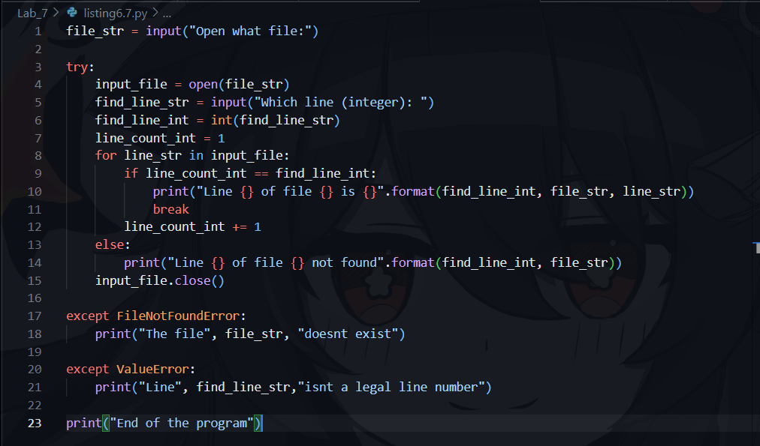
2. A screen shot of a computer screen

   Description automatically generated

